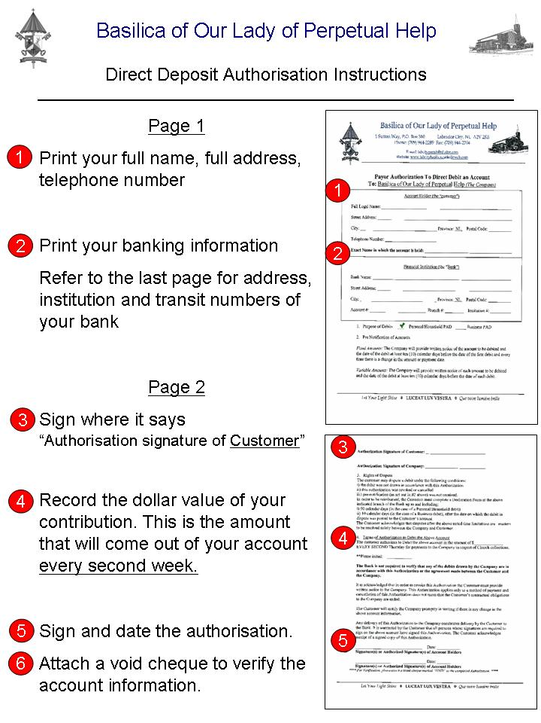
Basilica of Our Lady of Perpetual Help

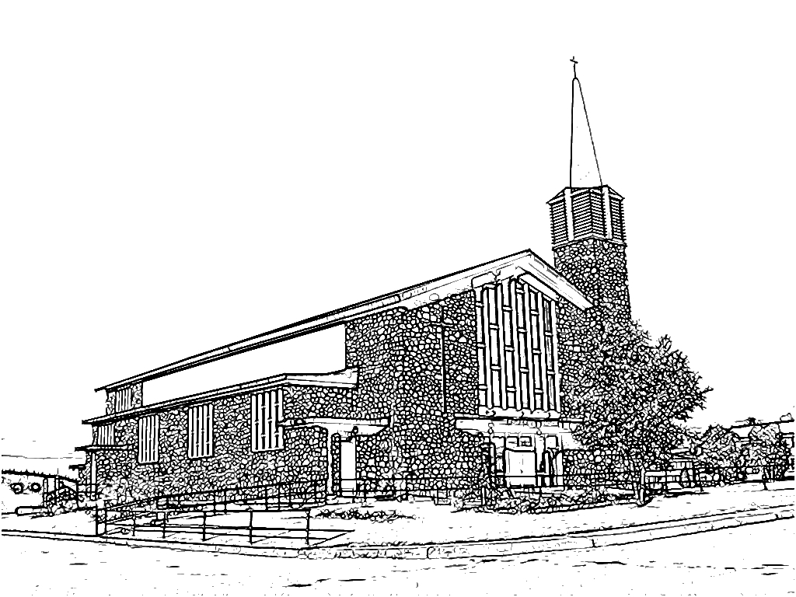1 Sutton Way, P.O. Box 310 Labrador City, NL A2V 2K6
Phone: (709) 944-2289 Fax: (709) 944-2704
E-mail: labcityparish@nf.aibn.com
Website: www.labcitybasilica.catholicweb.com

Payor Authorization To Direct Debit an Account

To: Basilica of Our Lady of Perpetual Help (The Company)

Account Holder (the “customer”)

Full Legal Name: _______________________________________________________________

Street Address: _________________________________________________________________

City: _____________________________________ Province: NL Postal Code: ___________

Telephone Number: _________________________

Exact Name in which the account is held: __________________________________________

Financial Institution (the “Bank”)

Bank Name: ____________________________________________________________

Street Address: _________________________________________________________________

City: _____________________________________ Province: NL Postal Code: ___________

Account #: ___________________________ Branch #: _________ Institution #: __________

- Purpose of Debits _____ Personal/Household PAD _____ Business PAD

- Pre Notification of Amounts

Fixed Amounts: The Company will provide written notice of the amount to be debited and the date of the debit at least ten (10) calendar days before the date of the first debit and every time there is a change in the amount or payment date.

Variable Amounts: The Company will provide written notice of each amount to be debited and the date of the debit at least ten (10) calendar days before the date of each debit.

Authorization Signature of Customer: _____________________________

Authorization Signature of Company: _____________________________

- Rights of Dispute
The customer may dispute a debit under the following conditions:
i) the debit was not drawn in accordance with this Authorization
ii) this authorization was revoked or cancelled
iii) pre-notification (as set out in #2 above) was not received.
In order to be reimbursed, the Customer must complete a Declaration Form at the above indicated branch of the Bank up to and including:
i) 90 calendar days (in the case of a Personal/Household debit)
ii) 10 calendar days (in the case of a Business debit), after the date on which the debit in dispute was posted to the Customer’s account
The Customer acknowledges that disputes after the above noted time limitations are matters to be resolved solely between the Company and Customer.

- Terms of Authorization to Debit the Above Account
The customer authorizes to Debit the above account in the amount of $______________ EVERY SECOND Thursday for payments to the Company in respect of Church collections.

**Please initial: ____________

The Bank is not required to verify that any of the debits drawn by the Company are in accordance with this Authorization or the agreement made between the Customer and the Company.

It is acknowledged that in order to revoke this Authorization the Customer must provide written notice to the Company. This Authorization applies only to a method of payment and cancellation of this Authorization does not mean that the Customer’s contractual obligations to the Company are ended.

The Customer will notify the Company promptly in writing if there is any change in the above account information.

Any delivery of this Authorization to the Company constitutes delivery by the Customer to the Bank. It is warranted by the Customer that all persons whose signatures are required to sign on the above account have signed this Authorization. The Customer acknowledges receipt of a signed copy of this Authorization.

__________________________________ Date: ___________

Signature(s) or Authorized Signature(s) of Account Holders

__________________________________ Date: ___________

Signature(s) or Authorized Signature(s) of Account Holders

** Please attach a blank cheque marked “VOID” to the completed Authorization. **

Bank Branches in Labrador City and Wabush

IMPORTANT:

Transit numbers and addresses listed below only pertain to accounts OPENED in LABRADOR CITY or WABUSH branch locations. If you opened your account in another city, you need to contact your bank to request the correct transit number.

BMO Bank of Montreal Transit # Institution #
P.O. Box 10 10221 001
Wabush NL, A0R 1B0

CIBC Transit # Institution #
208 Humber Avenue 00165 010
Labrador City NL, A2V 1L1

Bank of Nova Scotia Transit # Institution #
500 Vanier 60913 002
Labrador City NL, 2W7

NL Credit Union Transit # Institution #
500 Vanier 68020 809
Labrador City NL, 2W7

