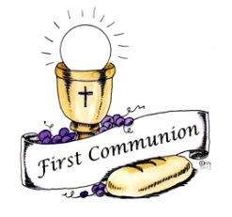
Sacramental Initiation Process
1st Communion Registration Form 2015-2016
PARISH: Our Lady of Perpetual Help, Labrador City
Our Lady of the Assumption, Wabush

NAME OF CANDIDATE:

First Middle Last

Address: Postal Code:
Phone #:
Date of Birth: Grade Level:
Parish of Baptism:
City/Town of that Parish: Province:
Please Note: A copy of the Baptism certificate is required if your child was baptized in a parish other than Labrador City or Wabush.

MEDICAL INFORMATION:

Any Allergies?
Any Medical Concerns?

CANDIDATE’S PARENTS:

Father’s Name: Phone #:
Address (if different):
Religious Denomination: E-mail:

Mother’s Name: Phone #:
Address (if different):
Religious Denomination: E-mail:

Candidates E-mail (if applicable):

NOTES:

